**😊 Kinesis Data Analytics**

Amazon Kinesis Data Analytics is a fully managed service that allows you to process and analyze real-time streaming data using SQL, Apache Flink, or custom applications. It integrates seamlessly with Kinesis Data Streams and Kinesis Data Firehose, allowing users to gain insights and make decisions based on real-time data.

**Key Features:**

1. **Real-Time Data Processing**: Kinesis Data Analytics can process streaming data in real-time, enabling users to respond to events as they happen (e.g., monitoring sensor data, analyzing clickstream data).
2. **SQL-Based Stream Processing**: You can use SQL queries to process and analyze data, which is beneficial for those familiar with databases. This enables transformations, aggregations, filtering, and joining streams of data.
3. **Apache Flink**: For more complex use cases, you can use Apache Flink, a popular open-source framework, for stateful stream processing. This allows for advanced data manipulation and machine learning use cases.
4. **Scalability**: The service automatically scales to accommodate the data throughput, so there is no need for manual intervention.
5. **Seamless Integration**: Kinesis Data Analytics integrates with other AWS services like Kinesis Data Streams, Firehose, S3, and Lambda, making it easy to use for a wide range of applications.

**Common Use Cases:**

* **Real-time analytics**: Analyze sensor data, logs, and transactions in real-time.
* **Monitoring and alerting**: Set up thresholds and alerts based on real-time data streams.
* **Data enrichment**: Clean and enrich data in real-time before storing it in data lakes or databases.

In short, Kinesis Data Analytics allows businesses to extract value from streaming data in real-time, helping make data-driven decisions quickly.

**😄 To begin with the Lab:**

1. What we will do is we'll first create an S3 bucket and then we’re going to create a kinesis firehose delivery stream along with that, we are also going to create a Kinesis data analytics application. Once that is complete, we'll configure an input stream, a real-time analysis, or the analytics query, and after that, we'll set up a delivery stream to store the results in the S3 bucket. And at the end, we'll go ahead and test the destination.
2. First, we are going to create an S3 bucket. So, go to S3 and create a bucket with unique name.

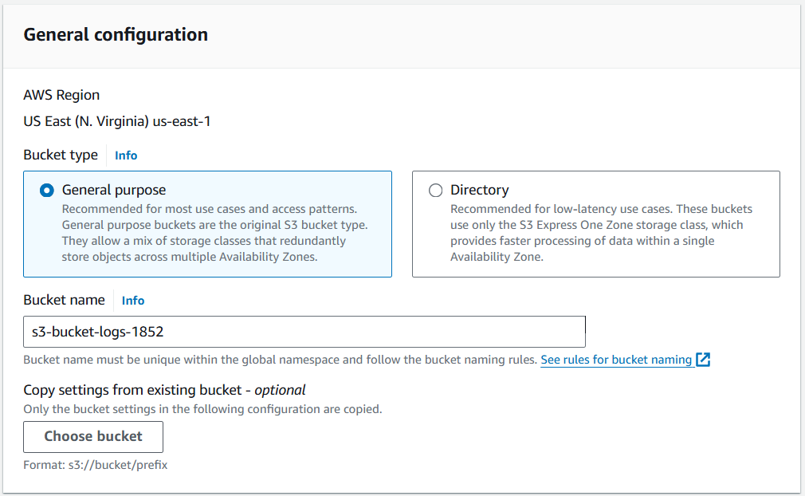

1. Then we need to create a Kinesis Data Firehose delivery stream. In this scenario, we are going to store our output analytics in an S3 bucket, so we need to configure Firehose.
2. Now go to Firehose and create your Data Firehose. Here you need to choose Source as Direct PUT and destination as Amazon S3.
3. So, Direct PUT is an option to create a data firehose delivery stream that the producer application writes to it in a direct fashion. Keep the stream name to default.

1. After that in the destination choose S3 bucket which you created earlier.

1. In the end, expand the buffer hints option and choose buffer size as 1 MiB and the buffer interval as 60 seconds.

1. Once your data Firehose Stream is active then you need to create Kinesis data Analytics.

1. On your AWS Console search for Data Analytics. Also, you will notice that its name has been changed to Amazon Managed Service for Apache Flink. Click on Create Steaming Application.

1. Here first you need to choose Create from Scratch. and choose the latest Apache Flink version.

1. Then give a name to your application and choose to create a new IAM role.

1. After that choose Development for your template and create your application.

1. Once your application is ready now you need to click on Configure.

